August X, 2022
www.troop-1.com

Committee Chairman
Frank Anselmi
Commchairanselmi.troop.1@gmail.com
916.548.7951

Scoutmaster
Chris Tileston
Smtileston.troop.1
@gmail.com
916.956-0248

Camp Cody Committee Chair
Ed Cargile
916.471.9303

Troop 1 Scout statistics 2021-2022:
- 40 Scouts, earning 70 rank advancements and 266 merit badges
- 10 Eagle Scouts
- 21 outings with 51 nights camping
- 20 hikes covering 188.9 miles
- 18 service projects, donating over 74 hours to the community
- Journey to Excellence, Gold Level
- National Camp Accreditation approved for Camp Cody

A Scout is:
- Trustworthy,
- Loyal,
- Helpful,
- Friendly,
- Courteous,
- Kind,
- Obedient,
- Cheerful,
- Thrifty,
- Brave,
- Clean, and
- Reverent.

Golden Empire Council,
Boy Scouts of America
501 (c) (3)

Dear Friend at _________,

We invite you to join us in supporting the missions of Boy Scout Troop 1 and Venture Crew 1 in our 9th Annual Crab Feed and Raffle Fundraiser. This event, which celebrates the development of future leaders to “BE PREPARED!” will be held on January 28th, 2023, from 5:30-10 PM at the California Automobile Museum, located at 2200 Front Street, Sacramento, CA 95818.

We need your help! Please consider donating ______ to our raffle drawing or Silent or Dessert Auction. This is a great way to promote your business and support your community at the same time.

Here is a little about who we are and what we do. Troop 1 of Sacramento, established in 1916 with the Boy Scouts of America, is the oldest continuously-chartered Boy Scout troop west of the Mississippi River! Troop 1 and Venture Crew 1 empower Scouts ages 11 through 20 take part in meaningful activities that encourage them to feel confident in the outdoors, solve problems cooperatively, and cultivate attitudes of respect, teamwork, and service to others.

Funds raised from the raffle and Silent / Dessert Auctions support troop and crew activities, including monthly outdoor outings, which include camping, hiking, boating, and biking through California’s national, state, and regional parks. The troop also hosts a 50-mile backpacking trek each summer, operates an 85-year-young summer camp in the Sierra Nevada, and facilitates Scout-led service projects that empower Scouts to improve their communities all year long.

Besides funding activities, equipment, and leadership training, funds raised at the Crab Feed also allow us to provide scholarship assistance to Scouts who might not otherwise be able to attend all the activities they wish to join.

Crab Feed attendees will enjoy fresh, hot crab and shrimp prepared on site, along with other yummy food, an entertaining stroll around the museum, live music, and of course, a boisterous raffle and Silent & Dessert Auctions! Based on previous Crab Feeds, we anticipate around 300 guests to attend – family members, leaders, public officials, and media representatives of Sacramento alike – who will gather to enjoy a good time and support our future leaders.

Troop 1 and Crew 1 hope that you’ll consider donating something to one of our auctions, and we thank you for whatever you’re willing to offer up! It’s an excellent opportunity to showcase your products / services to hundreds of new potential customers and support a good cause. If you have questions, please don’t hesitate to contact me at 916-548-7951 or by email at commchairanselmi.troop.1@gmail.com.

Sincerely,
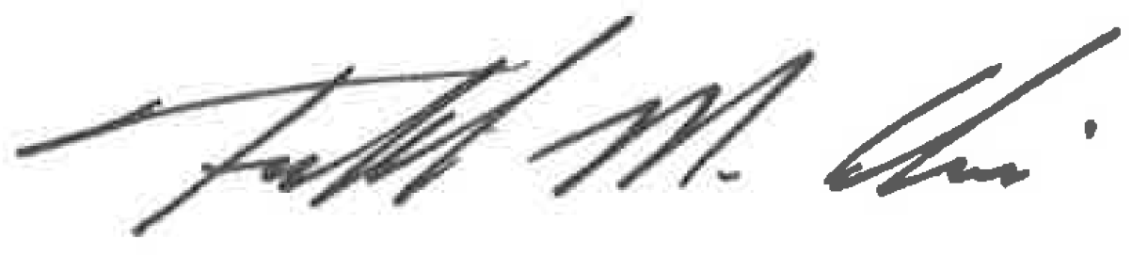

Frank Anselmi
Committee Chairman,
Troop 1 BSA Sacramento, CA

