August X, 2022
www.troop-1.com

Committee Chairman
Frank Anselmi
Commchairanselmi.troop.1@gmail.com
916.548.7951

Scoutmaster
Chris Tileston
Smtileston.troop.1
@gmail.com
916.956-0248

Camp Cody Committee Chair
Ed Cargile
916.471.9303

Troop 1 Scout statistics 2021-2022:
- 40 Scouts, earning 70 rank advancements and 266 merit badges
- 10 Eagle Scouts
- 21 outings with 51 nights camping
- 20 hikes covering 188.9 miles
- 18 service projects, donating over 74 hours to the community
- Journey to Excellence, Gold Level
- National Camp Accreditation approved for Camp Cody

A Scout is:
- Trustworthy,
- Loyal,
- Helpful,
- Friendly,
- Courteous,
- Kind,
- Obedient,
- Cheerful,
- Thrifty,
- Brave,
- Clean, and
- Reverent.

Golden Empire Council,
Boy Scouts of America
501 (c) (3)

Dear Friend at ___________,

Thank you for supporting our Troop 1 and Crew 1 Scouts as part of our 9th annual Crab Feed! The event, which enables the troop to help our Scouts “BE PREPARED” to be future leaders, was held on January 28, 2023 at the California Automobile Museum.

We are incredibly grateful for your donation of __________. Along with others, your donation to our Silent Auction, Dessert Auction, or raffle helped our troop raise over $________. Thanks to your generosity, Troop 1 will be able to continue empowering Scouts as they develop leadership, improve and hone their outdoor skills, and become all-around better citizens.

Sacramento’s Troop 1 was established in 1916 and commemorated its 100th anniversary six years ago. Our troop is the oldest continuously-chartered Boy Scout troop West of the Mississippi! Together with Venture Crew 1, our programs empower youth ages 11 through 20 to become good citizens and leaders in their community. Troop 1 and Crew 1 provide our youth with effective programs designed to build fitness and a love of the outdoors, as well as leadership skills and character. We foster their abilities to do things for themselves and let the Scouts lead by example as they learn the importance of serving others. Our Scouts take part in weekly meetings, monthly outdoor camping trips, Scout-led community service projects, and 1-2 weeks at our troop’s off-the-grid summer camp in the Sierra Nevada.

Your support this year means our troop can keep offering outdoor experiences and leadership opportunities that will stick with them for life…especially for Scouts who may not otherwise be able to afford to join. THANK YOU for making all our Scouts’ experiences more robust!

Over 300 guests attended this year’s Crab Feed – including family members, friends, public officials, and media representatives alike – and Troop 1 and Crew 1 are thankful for your support of our Scouts. If you have any follow-up questions, please don’t hesitate to contact me at 916-548-7951 or by email at committeechair@troop-1.com.

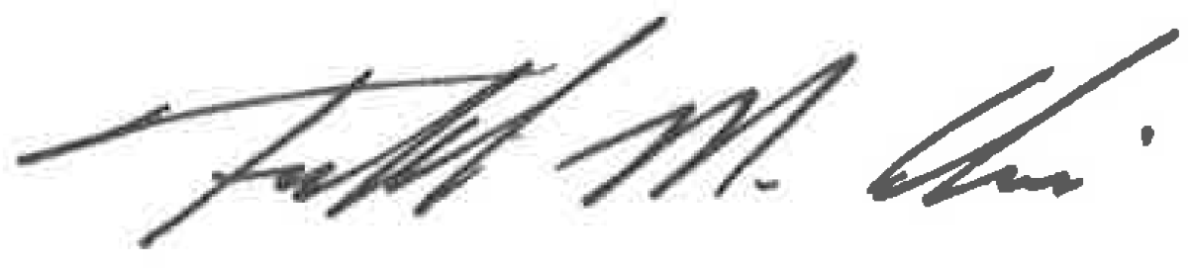
Sincerely,

Frank Anselmi
Committee Chairman,
Troop 1 BSA Sacramento, CA

